**Project documentation: Home Savvy - Smart Home Expense Accounts Management App**

**Project Name:** Home Savvy

**Key Features:**

**Expense Account Creation and Management**: Users can create multiple accounts within the app based on their specific financial requirements.

Account types include saving accounts for managing electricity bills, business accounts for side hustles, and check accounts for day-to-day expenses.

Each account can be personalized with relevant details such as account names, targets, and budget limits.

**Expense Tracking and Analysis:** Home Savvy offers a user-friendly interface to input and track various expenses across different accounts.

Users can categorize expenses for better organization and analysis.

The app provides comprehensive expense reports and visualizations to monitor spending patterns and identify areas for potential savings.

**Deposit and Payment Management:** Users can conveniently deposit money into their accounts, and they can later transfer their money to different created home accounts.

**Database Diagram**

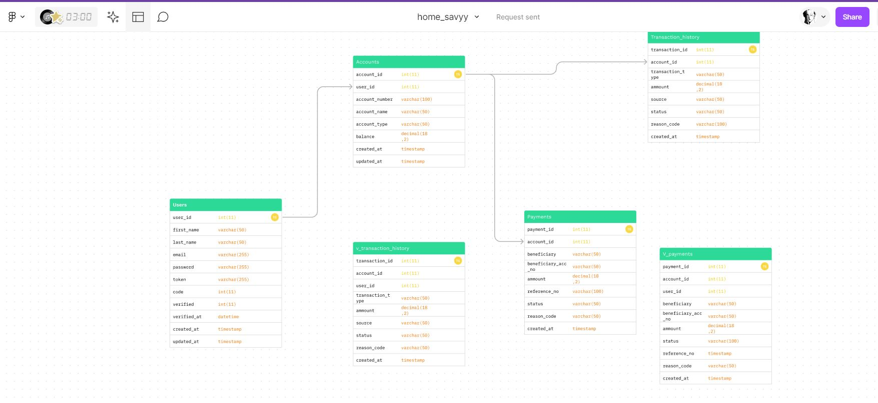

**Dependencies**

<dependencies>

<dependency>

<groupId>org.springframework.boot</groupId>

<artifactId>spring-boot-starter-data-jpa</artifactId>

</dependency>

<dependency>

<groupId>org.springframework.boot</groupId>

<artifactId>spring-boot-starter-mail</artifactId>

</dependency>

<dependency>

<groupId>org.springframework.boot</groupId>

<artifactId>spring-boot-starter-web</artifactId>

</dependency>

<dependency>

<groupId>mysql</groupId>

<artifactId>mysql-connector-java</artifactId>

<scope>runtime</scope>

</dependency>

<dependency>

<groupId>org.springframework.boot</groupId>

<artifactId>spring-boot-starter-test</artifactId>

<scope>test</scope>

</dependency>

<dependency>

<groupId>org.springframework</groupId>

<artifactId>spring-jdbc</artifactId>

<version>5.3.2</version>

</dependency>

<dependency>

<groupId>org.springframework.boot</groupId>

<artifactId>spring-boot-starter-tomcat</artifactId>

<scope>provided</scope>

</dependency>

<dependency>

<groupId>org.apache.tomcat.embed</groupId>

<artifactId>tomcat-embed-jasper</artifactId>

<scope>provided</scope>

</dependency>

<dependency>

<groupId>org.springframework.boot</groupId>

<artifactId>spring-boot-starter-validation</artifactId>

<version>2.4.1</version>

</dependency>

<dependency>

<groupId>javax.servlet</groupId>

<artifactId>javax.servlet-api</artifactId>

<version>3.1.0</version>

</dependency>

<dependency>

<groupId>javax.servlet.jsp</groupId>

<artifactId>javax.servlet.jsp-api</artifactId>

<version>2.3.2-b02</version>

<scope>provided</scope>

</dependency>

<dependency>

<groupId>javax.servlet</groupId>

<artifactId>jstl</artifactId>

<version>1.2</version>

</dependency>

<dependency>

<groupId>org.springframework.security</groupId>

<artifactId>spring-security-crypto</artifactId>

<version>5.4.2</version>

</dependency>

</dependencies>

**Screenshots**

**Registration Page**

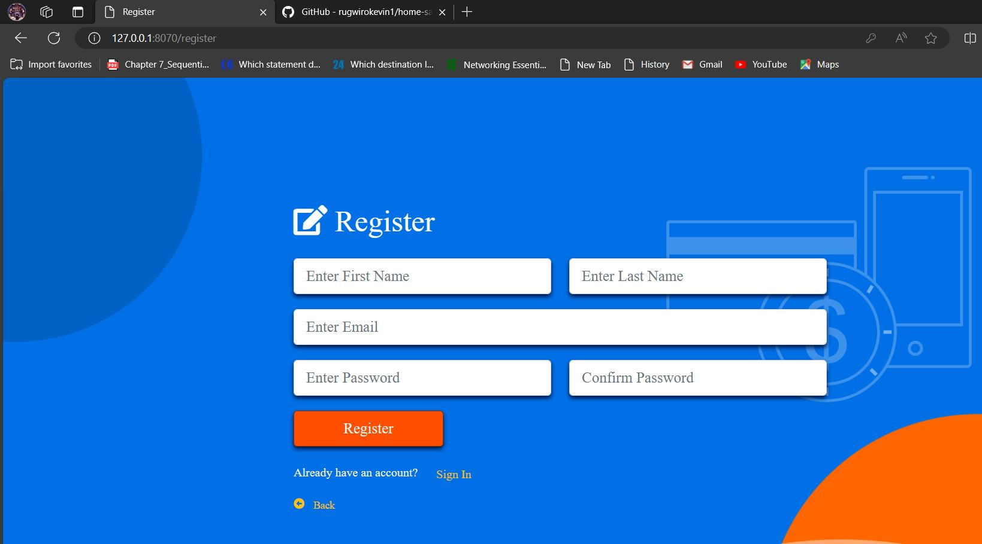

**Login Page**

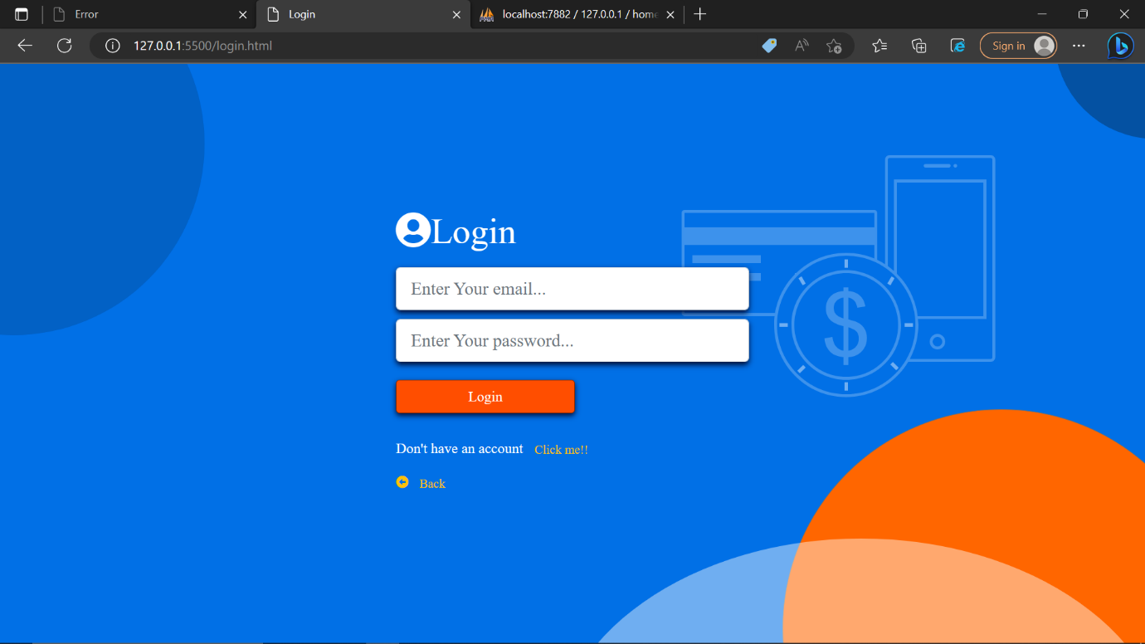

**Dashboard Page**

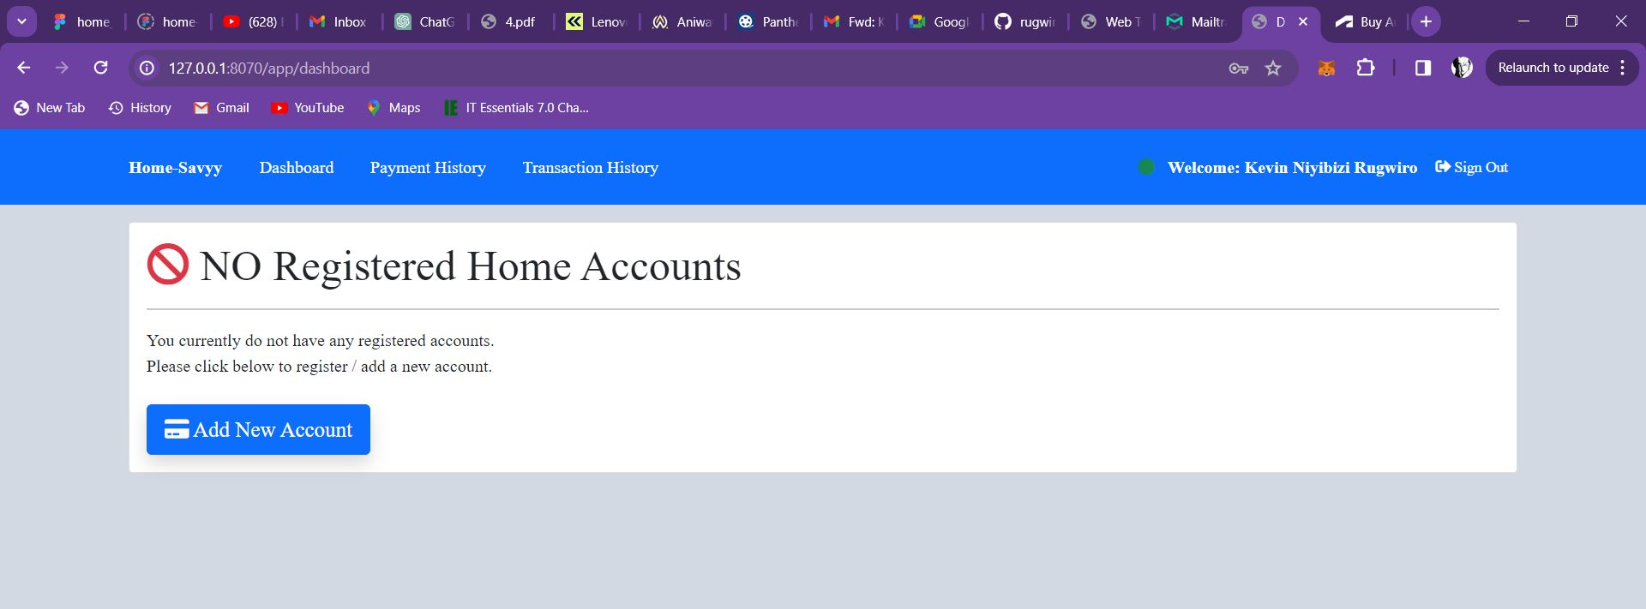

**Creating an account**

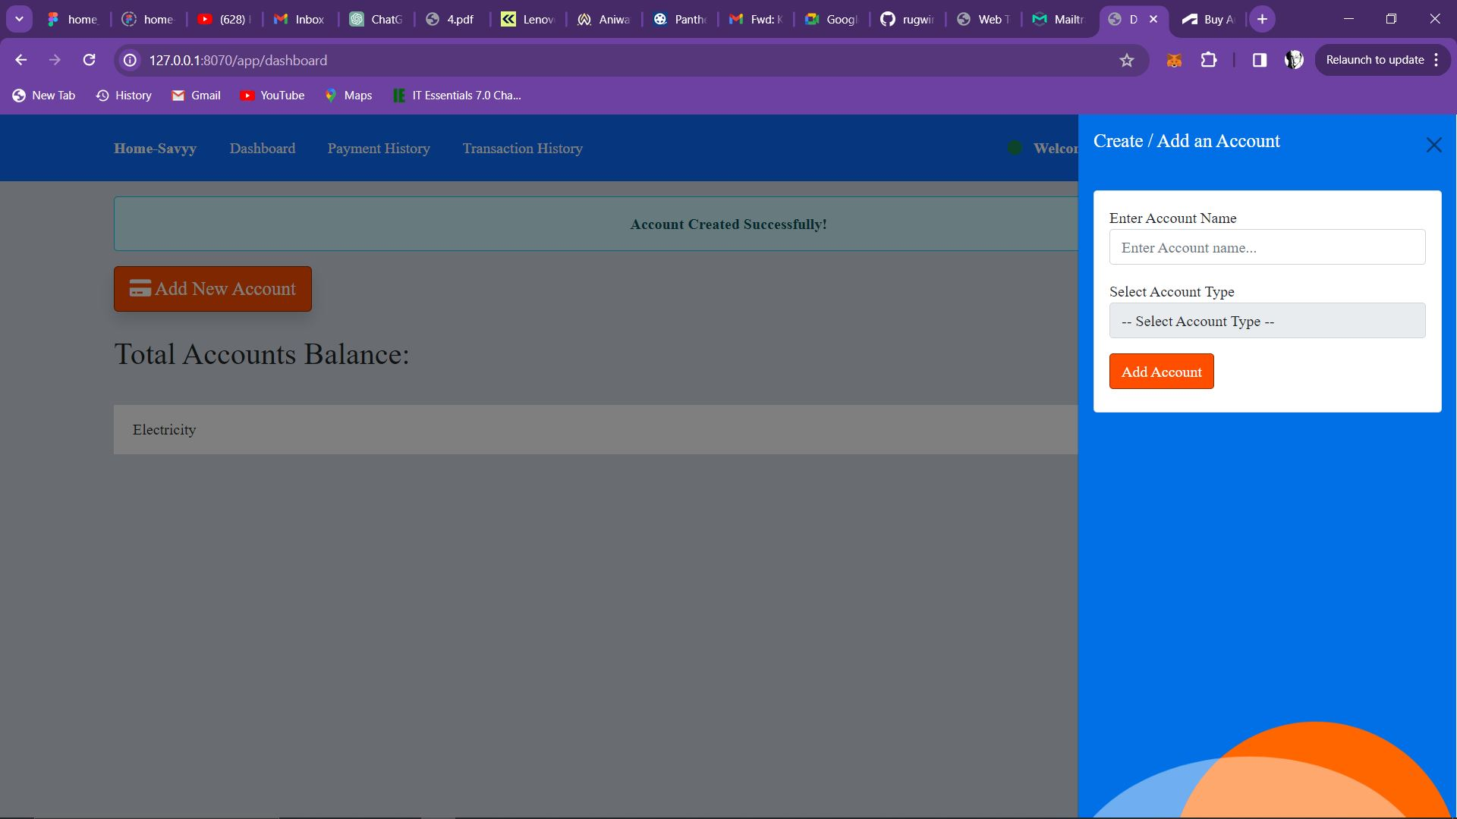

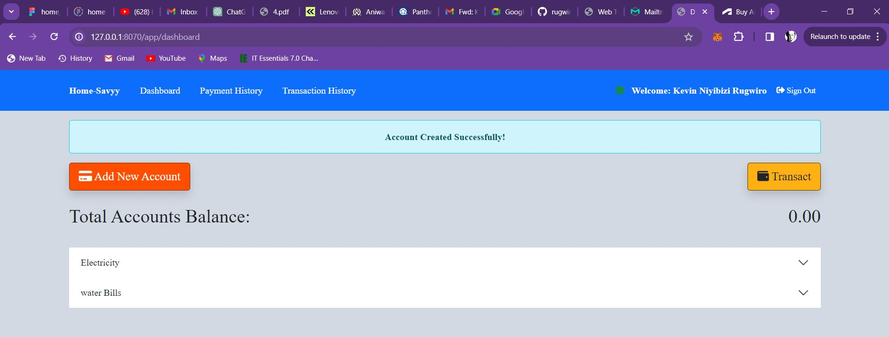

**Deposit**

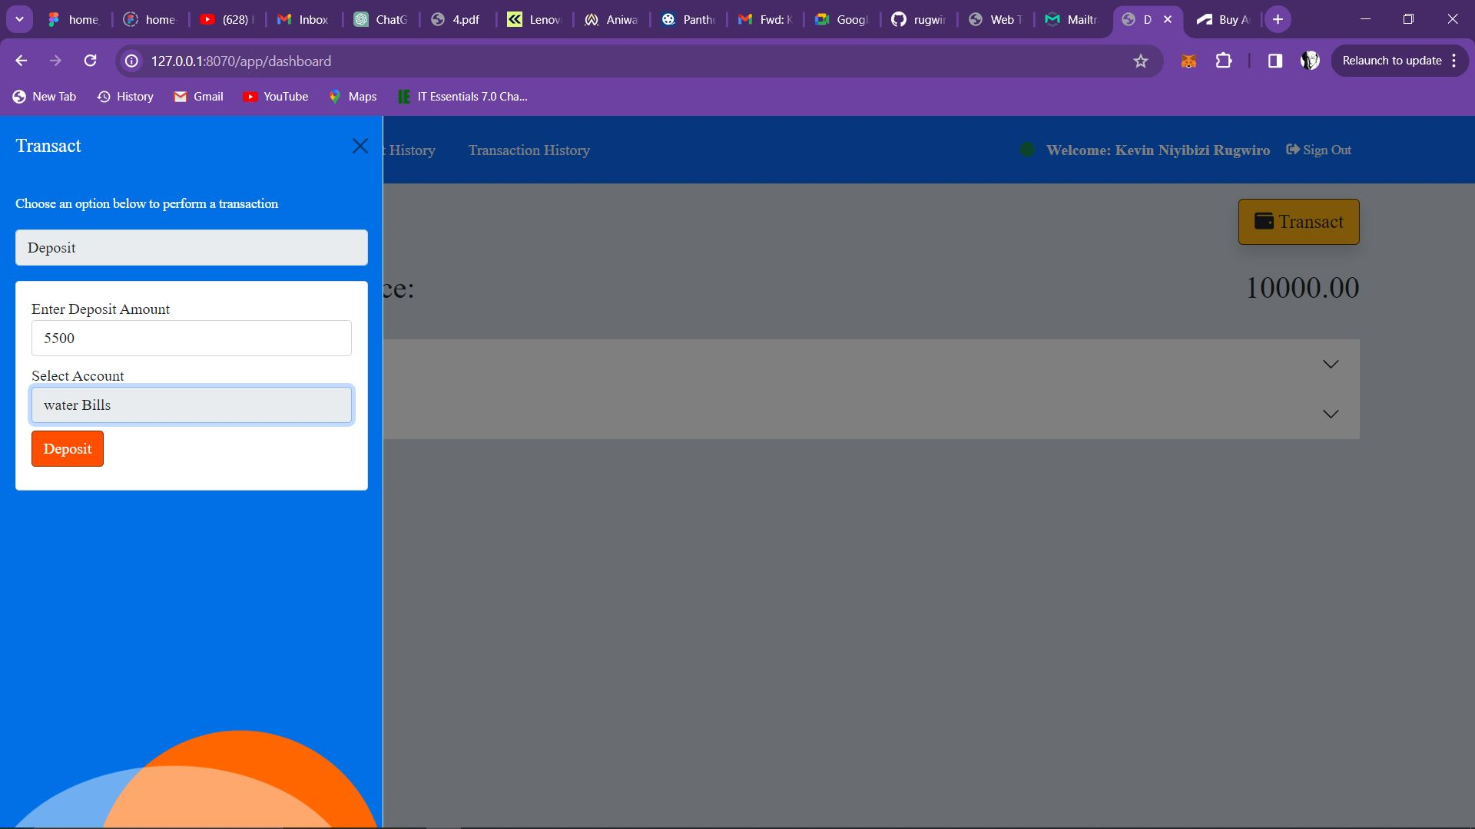

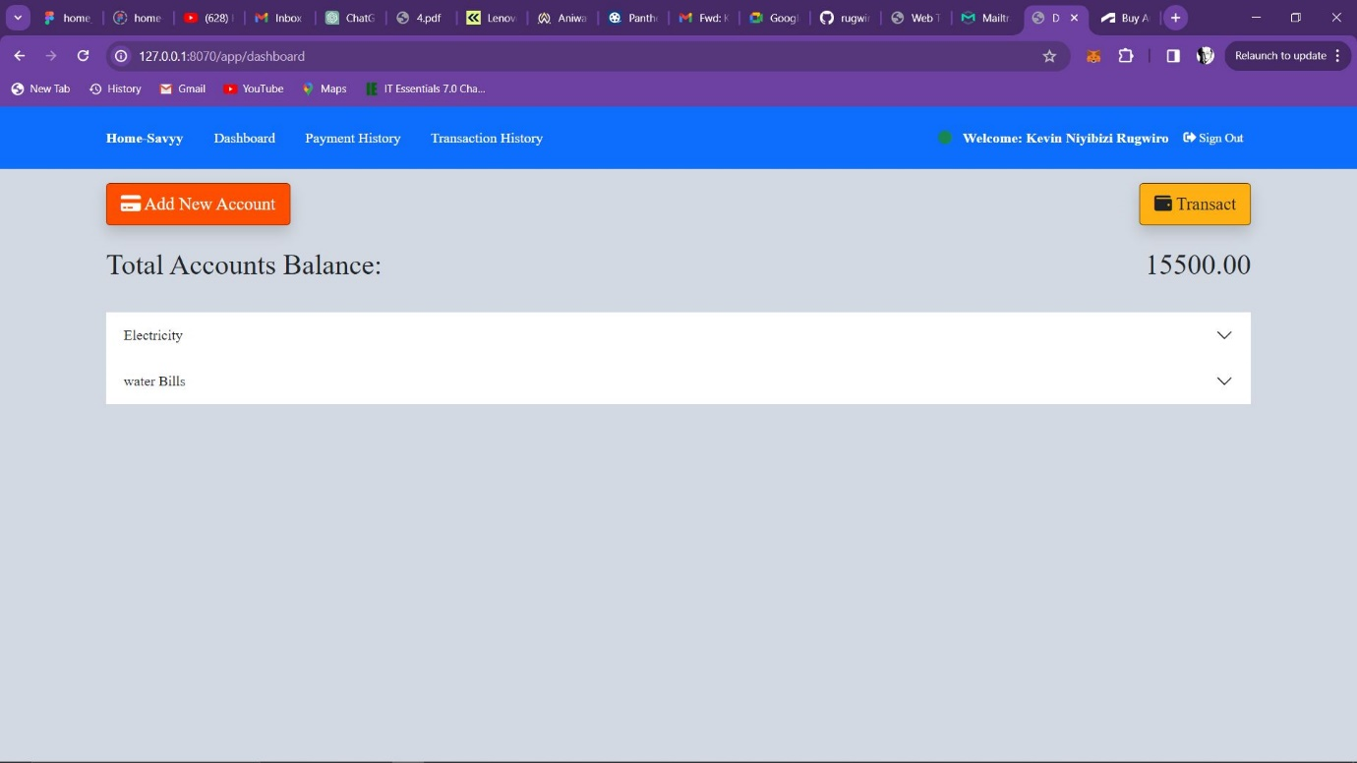

**Payment history**

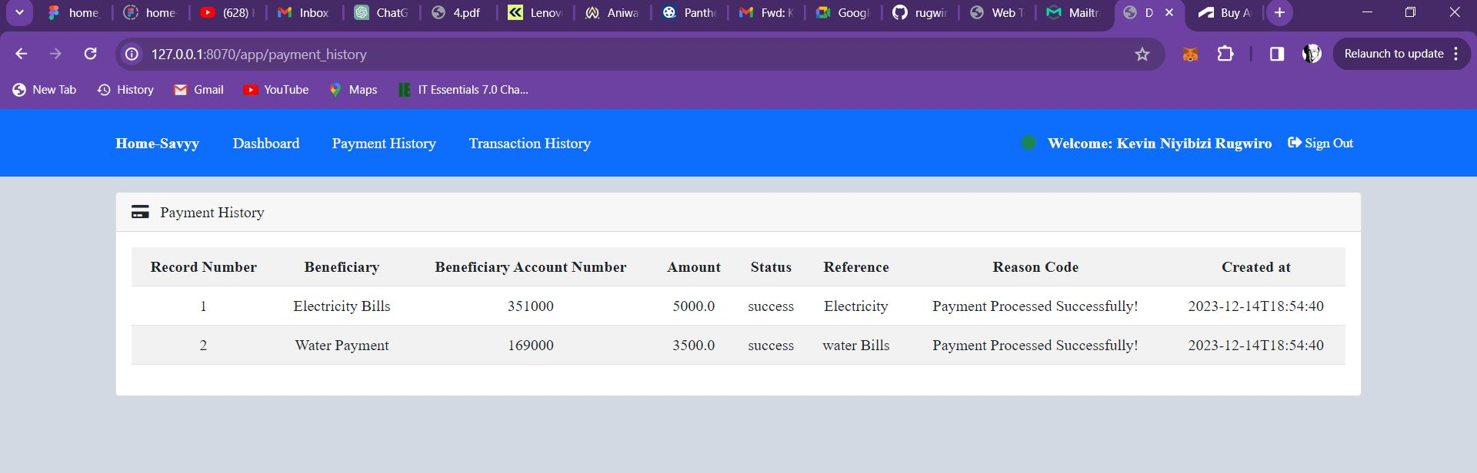

**Transaction history(shows both successful and failed transactions)**

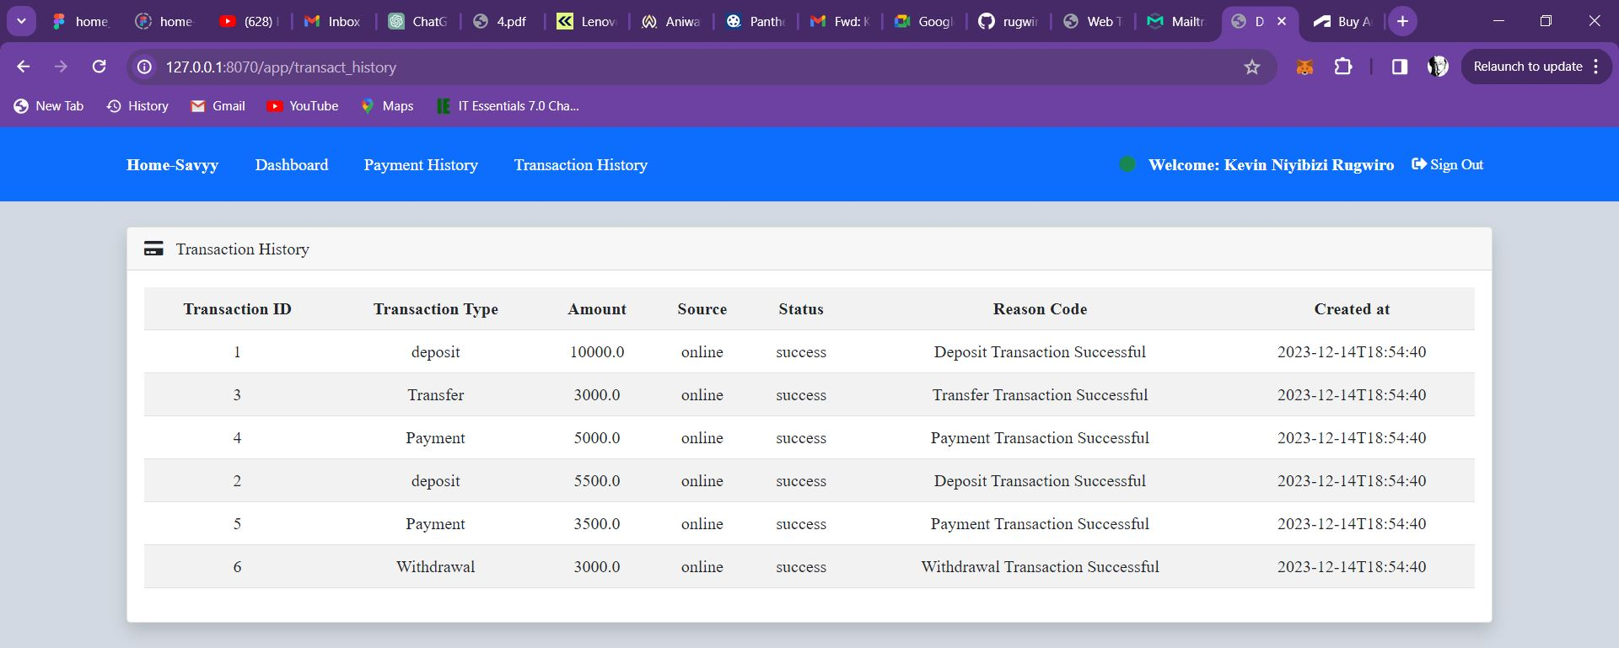

**PROTOTYPE:** <https://www.figma.com/file/YRRPB6HbNBLNrJ0vvfdHyM/home-savvy?type=design&node-id=5-162&mode=design&t=11b81JNCnN3lsGUb-0>

**DATABASE DESIGN** : <https://www.figma.com/file/GKp8aNOteSuagYd1PBEtGF/home_savyy?type=whiteboard&node-id=0-1&t=dZH7qoJdvRzyPxL4-0>

**23666: Git-hub-link:** [GitHub - rugwirokevin1/home-savyy at master](https://github.com/rugwirokevin1/home-savyy/tree/master)